**Round Roasters Market Test Analysis**

Round Roasters is considering adding wine and sandwiches to their menu. They would like to understand the gross margin impact of this change and whether they should implement the expanded menu in more stores.

Within the Central and West Regions, 10 stores piloted the new menu from April 29, 2016 to July 21, 2016.

In our A/B analysis we used gross margin as the final performance measure. Transactional fact data was aggregated to the week timeframe. Otherwise, no other imputation was needed for this analysis.

In order to match treatment units to two control units, we first used the A/B trend tool to find seasonality and trend for the number of transactions per store per week. The trend tool required 76 weeks of data. 64 weeks prior to the start date was used to calculate trends and 12 weeks for the test.

Apart from trend and seasonality, we considered square foot and average monthly sales from the round roaster stores data file, as other variables to match treatments and controls. However, by examining the correlation matrix of these variables, we can see that square foot has a very low correlation with gross margin, our performance measure, whereas average monthly sales is correlated by approximately 77%.

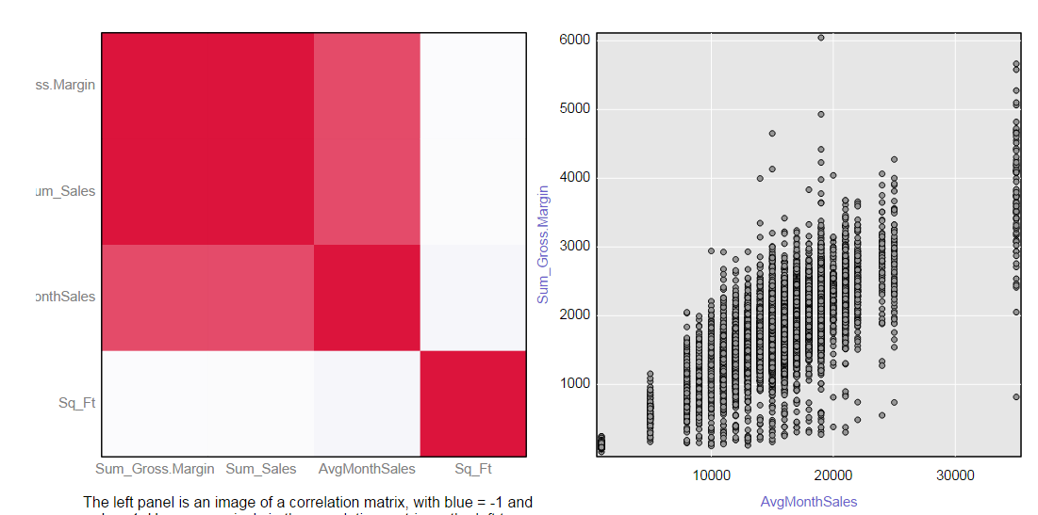

Using seasonality, trend, and average monthly sales, the following control units were assigned to each treatment unit. For this analysis, there are 2 control stores for each treatment store.

Central Region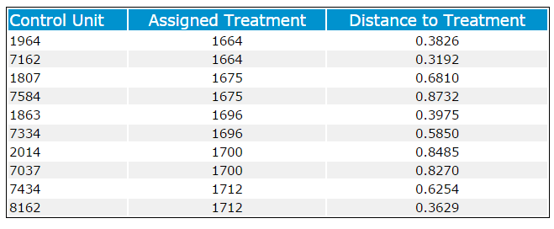

West Region

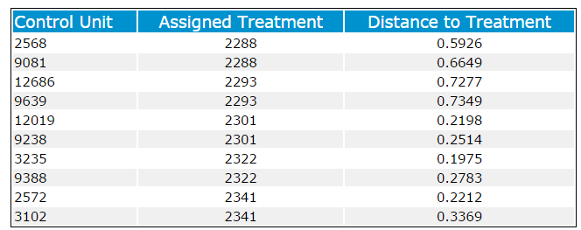

**Recommendation**

Round Roasters should roll out the expanded menu of wine and sandwiches to more stores.

The average percent change in Gross Margin for the treatment units in the test period relative to the comparison period in the Central region was 39.2%. A comparison between treatment and control shows a lift in Gross Margin of 39.6%.



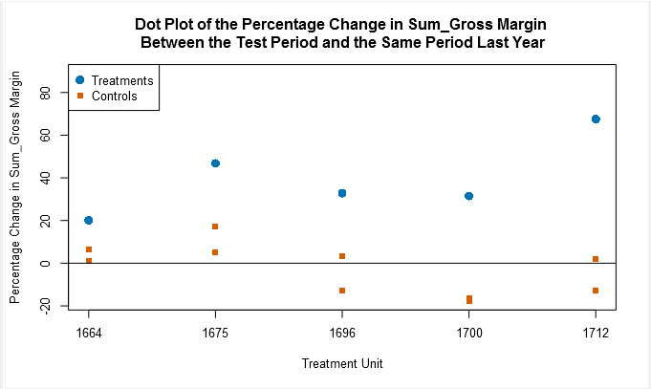

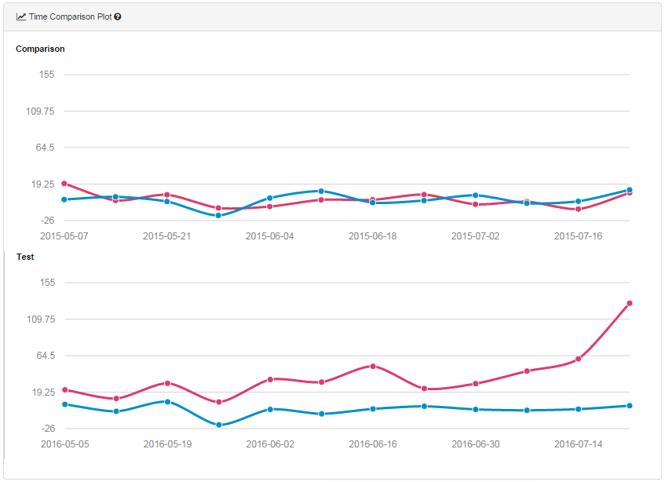

The average percent change in Gross Margin for the treatment units in the test period relative to the comparison period in the West region was 42.2%. A comparison between treatment and control shows a lift in Gross Margin of 45.1%.



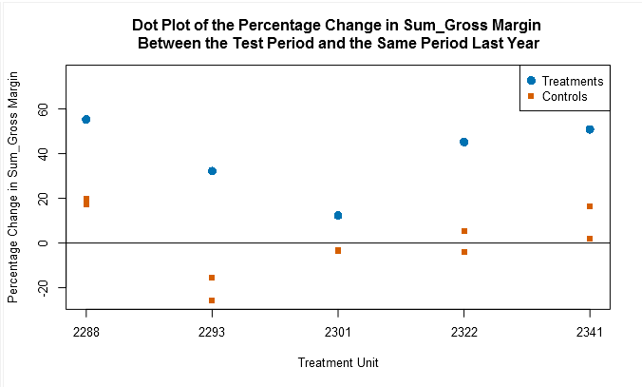

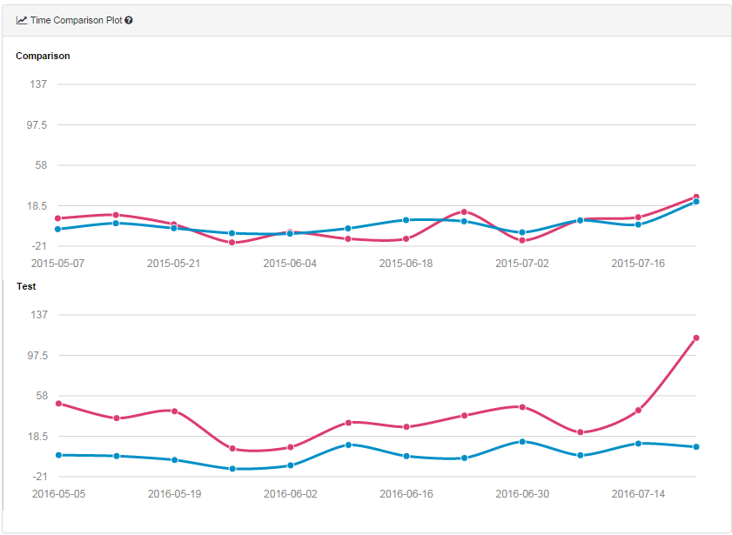

In the Central and West region, we observe that the lift is highly statistical significant, 99.6%.

The overall lift from the new menu is 42.3%.

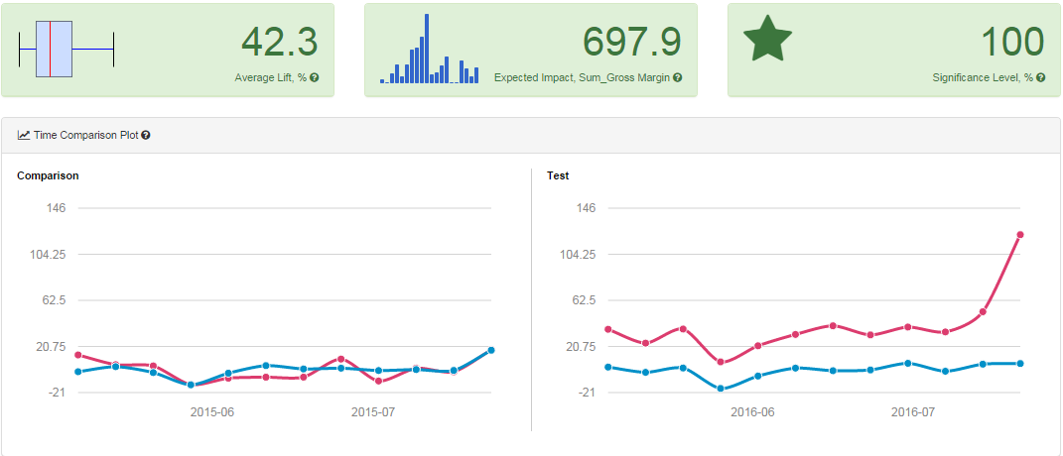

Whether examining the Central and West regions independently or the impact of the expanded menu overall, the test timeframe graphs illustrate how the treatment stores outperformed the control stores. Comparing the same timeframe last year, the treatment and control stores had similar gross margin values.